Wendy Bowen

Memo

|  |  |
| --- | --- |
| To: | ARC Co. Senior Management |
| From: | Wendy Bowen |
| Date: | January 2, 2015 |
| Re: | Status of Red Zuma Project |

I am writing to provide an update on the status of the Red Zuma Project. As of our current assessment, the project is estimated to be completed by January 11, 2016, requiring a total of 260 days for completion.

One significant aspect of our project analysis is the identification of slack within the detailed marketing plan. The detailed marketing plan exhibits the greatest amount of slack, totaling 179 days. For a more visual representation, please refer to the attached charts.

It is crucial to note that this project is highly sensitive, with over two-thirds of its components being critical. Any alterations or deviations from the current plan would significantly impact the timely completion of the project.

Identifying sensible milestones within the project timeline is essential for effective management. Two milestones stand out as particularly significant: the finalization of product design and the product design selection. Both milestones are pivotal, as they have multiple activities depending on them. Furthermore, these activities occur later in the project timeline and are therefore more sensitive to changes due to past slack time.

We must maintain a keen focus on adhering to the current project schedule and milestones. Any deviations or delays could have severe implications for the overall completion timeline.

I remain available for any further discussion or clarification regarding the project status.

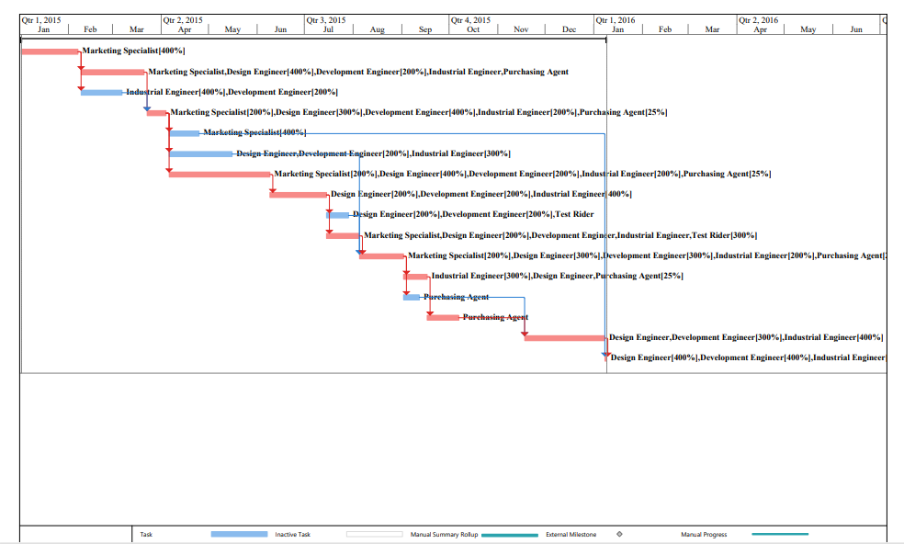

Wendy Bowen

Memo

|  |  |
| --- | --- |
| To: | ARC Co. Senior Management |
| From: | Wendy Bowen |
| Date: | March 3, 2015 |
| Re: | Status of Red Zuma Project |

I am writing to provide an important update on the status of the Red Zuma Project.

During our recent project analysis, it has come to my attention that certain resources within the project are overallocated. Specifically, the following roles are experiencing overallocation: marketing specialist, design engineer, and industrial engineer.

Given the time constraints of the project, I took the initiative to address these overallocations by attempting to level resources within slack. This has helped but did not completely take care of our overallocation issue. By using the slack, we have increased our sensitivity of the network, but our overall amount of slack has decreased substantially. It is important to note that the project is also resource-constrained, and no additional personnel are available to alleviate the overallocation issues. Regrettably, the project will inevitably take longer to complete than initially anticipated.

We no longer have any allocation issues, but our duration has been extended to 295 days with a completion date of February 26, 2016. This change in completion date directly correlates with our inability to procure additional resources and the necessity for leveling within the existing resource pool.

I have attached a chart illustrating the effects of leveling slack on the project timeline for your reference.

I understand the importance of meeting deadlines and delivering on our commitments. Rest assured, I will continue to explore alternative solutions and strategies to mitigate the impact of resource constraints on the project timeline.

**LEVELING ONLY WITHIN AVAILABLE SLACK**

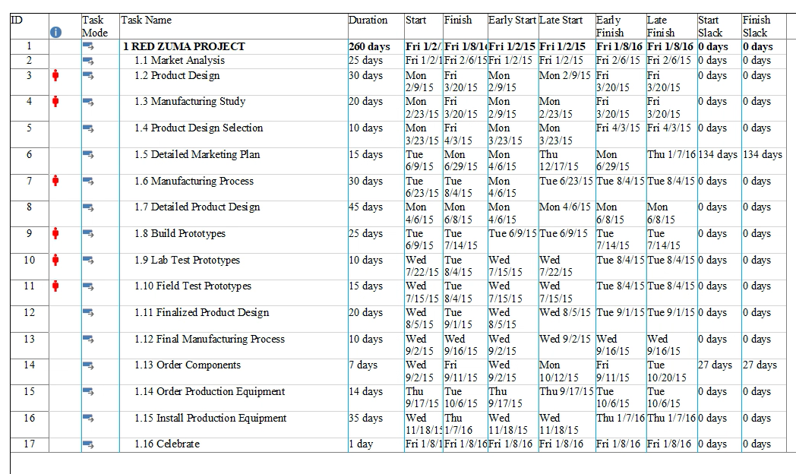

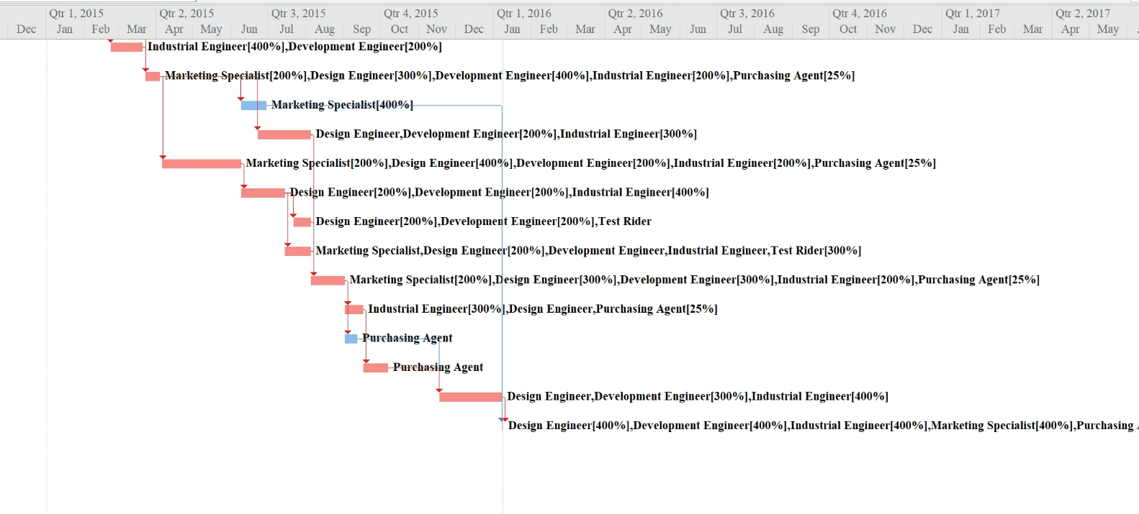

LEVEL ALL

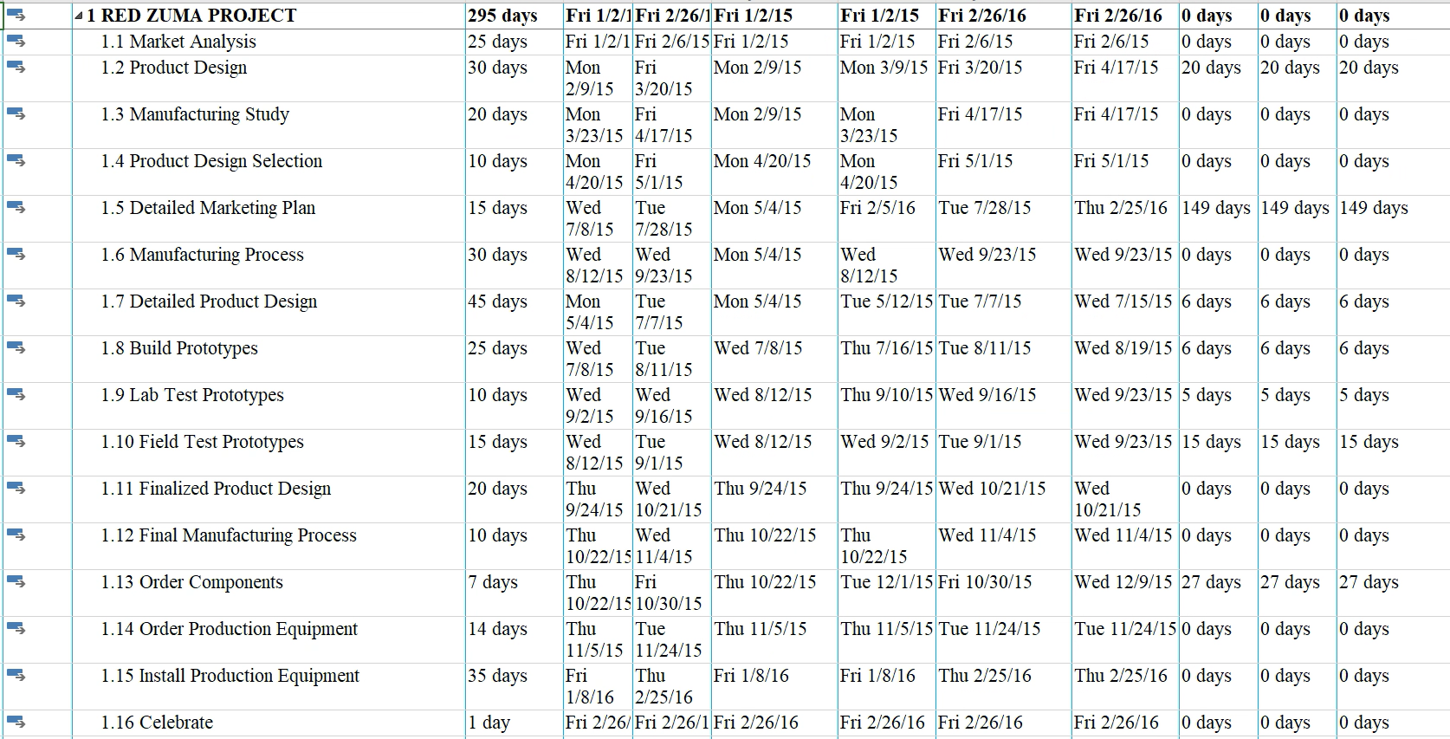

Wendy Bowen

Memo

|  |  |
| --- | --- |
| To: | ARC Co. Senior Management |
| From: | Wendy Bowen |
| Date: | May 6, 2015 |
| Re: | Status of Red Zuma Project |

I am writing to provide an update on the status of the Red Zuma Project and to share some recent developments.

As part of our ongoing efforts to optimize the project schedule and budget, we analyzed the impact of introducing start-to-start lags. However, after a thorough examination, it became evident that this adjustment did not produce any significant impact on either the project schedule or budget.

I want to express my gratitude for the opportunity provided to add personnel to the project team. After careful consideration and analysis, the decision was made to add another industrial engineer to our resources. This decision was based on the observation that adding an industrial engineer to the resource sheet resulted in a reduction in the project duration, unlike the addition of other resources. Adding an industrial engineer is the greatest benefit for the project.

The sensitivity of the network and critical path were notably increased. Our critical path now includes marketing analysis, product design, product design selection, build prototypes, manufacturing process, finalize product design, final manufacturing process, order production equipment, install production equipment, and celebrate.

I believe that this strategic allocation of resources will significantly contribute to the overall success of the Red Zuma Project. Our duration has been reduced to 270 days with a project completion date of January 6, 2016. I am confident that we are now better positioned to meet our project objectives within the specified schedule and budget constraints.

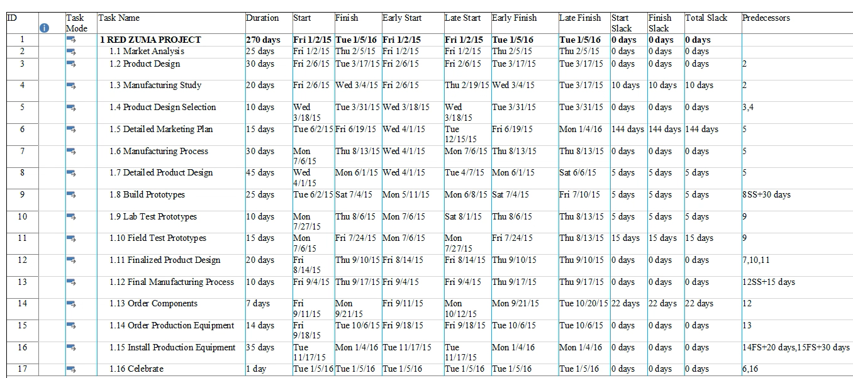

Wendy Bowen

Memo

|  |  |
| --- | --- |
| To: | ARC Co. Senior Management |
| From: | Wendy Bowen |
| Date: | June 1, 2015 |
| Re: | Status of Red Zuma Project |

I am writing to provide an update on the status of the Red Zuma Project.

As of our latest assessment, the total cost of the project stands at $912,160.58. It is worth noting that the most expensive activity within the project is the Detailed Product Design phase at $190,168.27.

In terms of our financial performance, the current cash flow statement indicates we are on budget. While expenses have remained relatively low in the initial month, you will observe a significant increase in expenses throughout the first quarter and that increase is expected to remain through the second quarter. However, it is important to highlight that expenses level off and begin to decrease into the third quarter and towards the end of the project. I have included a monthly cash flow report for you.

This fluctuation in expenses is a normal occurrence in project management, often reflecting the varying resource requirements and activity intensity throughout different phases of the project lifecycle.

Overall, the project remains on track in terms of budgetary targets. Our diligent monitoring and management of expenses have ensured that we are effectively managing costs within the allocated budget.

Wendy Bowen

Memo

|  |  |
| --- | --- |
| To: | ARC Co. Senior Management |
| From: | Wendy Bowen |
| Date: | July 8, 2015 |
| Re: | Status of Red Zuma Project |

I am writing to provide an important update on the status of the Red Zuma Project.

As of our latest assessment, the project is approximately 46% complete. However, I regret to inform you that we are currently $34,732.57 over budget. The majority of these overages occurred during the completion of the product design phase, with the most significant costs incurred in the Detailed Product Design stage. Smaller costs were also accrued during the Product Design Selection phase.

On a positive note, the Manufacturing Study was completed under budget, which partially mitigates the overall budget overrun.

The Estimate at Completion (EAC) for the project is now calculated to be $973,000, with a Variance at Completion (VAC) of -$69,000. If we continue on our current trajectory, the project is forecasted to exceed the budget by over $70,000.

Furthermore, the Earned Schedule Value (ESV) analysis reveals that there is more than $82,000 worth of work that has not been completed as planned.

In addition to budget concerns, we are currently 16 days behind schedule, with a projected completion date of February 1, 2016.

Given these challenges, we are taking immediate action to address the budget overrun and schedule delays.

Wendy Bowen

Memo

|  |  |
| --- | --- |
| To: | ARC Co. Senior Management |
| From: | Wendy Bowen |
| Date: | 9/1/2015 |
| Re: | Status of Red Zuma Project |

I am writing to provide you with an update on the status of the Red Zuma Project, including some revisions to our estimates and recommendations moving forward.

Upon reviewing our project plan and recent progress, I'm pleased to inform you that there have been some positive developments. The revised estimates for finalizing the product design and installing production equipment have been adjusted, resulting in minimal impact on the Estimate at Completion (EAC). These adjustments have removed 6 days from the project duration.

Furthermore, our analysis indicates that we should spend no more than $25000 expediting the shipment of parts. Since this is not a critical path activity, it will not significantly impact the overall project schedule.

Based on the revised estimates and current progress, the estimated completion date for the Red Zuma Project is now January 14, 2016. This suggests that we are on track to completing the project earlier than initially anticipated.

Considering these developments, should we experience any further delays, I would recommend that we postpone any celebrations or milestone acknowledgments until after the Las Vegas show. This will allow us to maintain our focus on completing the remaining tasks and ensuring a successful presentation at the event.